**Winter Data Analysis**

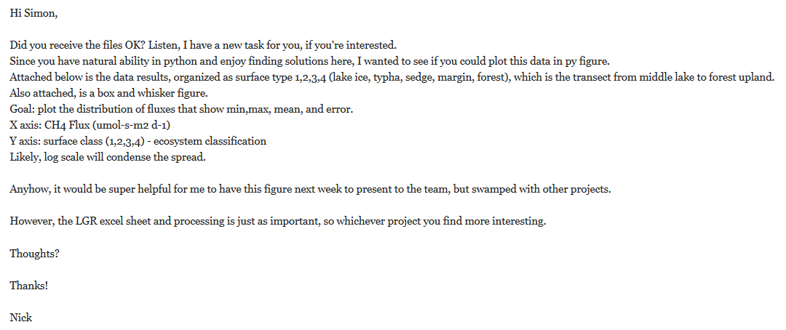

* Plot individual flux distributions, IE measurements at the individual spots